Supplementary Information for:
Impedance-based study of capacitive porous carbon electrodes with hierarchical and bimodal porosity
Matthew E. Suss, Theodore F. Baumann, Marcus A. Worsley, Klint A. Rose, Thomas F. Jaramillo, Michael Stadermann, Juan G. Santiago
SI1: Effect of transport pore capacitance on model results
Inclusion of the transport pore capacitance, C_{t}, in the circuit model has a significant impact on the predicted electrode impedance, even for the case where C_{t} << C_{s}. In Figure SI1, we show electrode impedance curves for the case of R_{s} = 45 Ω, R_{t} = 30 Ω, C_{s} = 0.5 F, and separate curves for the cases of C_{t} = 0.01 F, and C_{t} = 0. The parameters used in the former curve are approximately those obtained from data to experiment fits for the unactivated HCAM material (see Table 1 in the main paper). From Figure SI1, at C_{t} = 0 we do not observe 45° phase angle near the origin, but this feature is seen for C_{t} = 0.01 F. Further, in our experimental EIS data of the unactivated sample, we had observed a 45° phase angle near the origin (see Figure 6 inset in the main paper). Thus, inclusion of the parameter C_{t} in our circuit model was crucial to obtaining reasonable fits to the measured impedance of the unactivated HCAM.
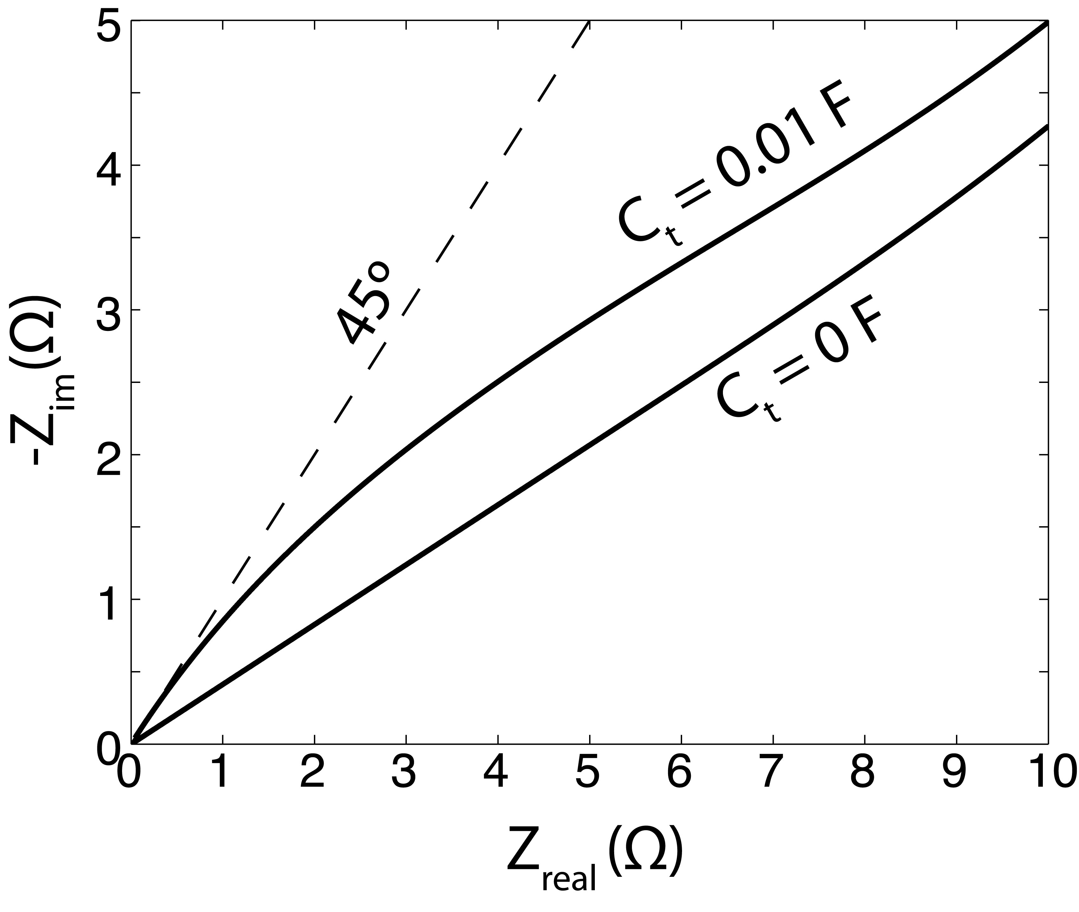
Figure SI1: Effect of transport pore capacitance, C_{t}, on complex impedance (Nyquist plot). Shown are circuit model results for C_{t} = 0.01 F and C_{t} = 0. The parameter C_{t} strongly influences the phase angle near the origin.
Appendix SI2: Additional SEM images of the HCAM electrodes
In Figure SI2, we show additional scanning electron microscopy (SEM) images of our unactivated and 5 h activated HCAM samples. Figure SI2a shows the unactivated HCAM transport pore network, and Figure SI2b is a close-up view of the transport pore wall. Figure SI2c shows the activated HCAM tranport pore network, and Figure SI2d is a close-up view of the transport pore wall. In Figure SI2d, we see evidence of fine features (order 10 nm, near the SEM resolution limit). These features are not present in Figure SI2c, and so are likely the result of the thermal activation step. We account for such fine scale structures in our model as storage pores
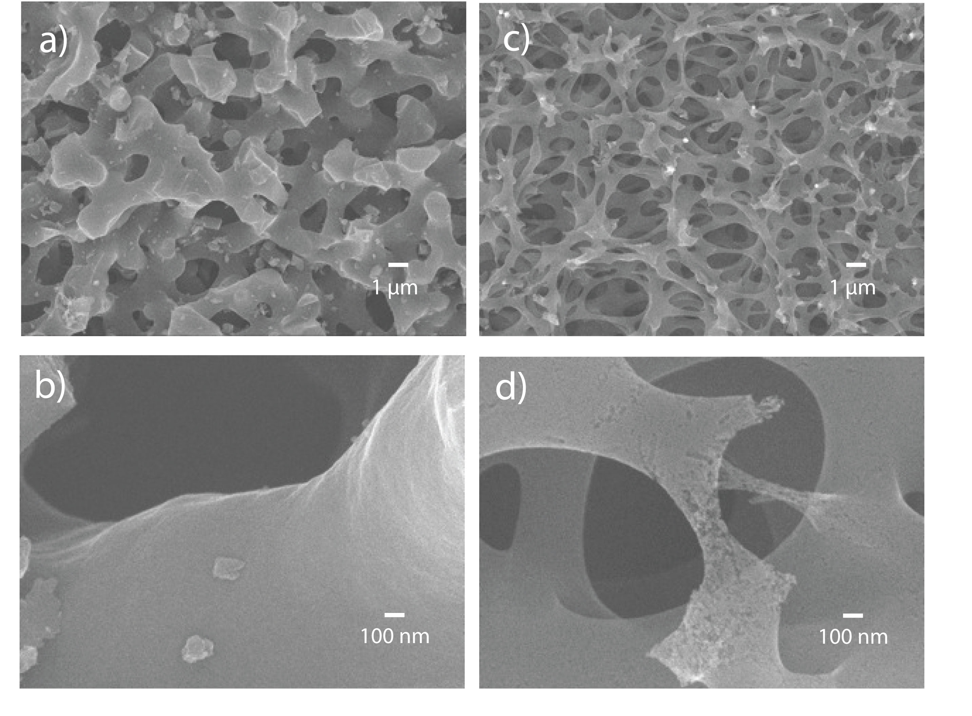
Figure SI2: SEM images of a), b) an unactivated, and c), d) a 5 h activated HCAM sample. Images b), d) are close-ups of the transport pore walls. Activation results in fine scale features with length scales on the order of, or smaller than, the resolution of the visualization technique.

Appendix SI3: Electrochemical impedance spectroscopy results for 0.5 M NaCl
In Figure SI3, we show the results of electrochemical impedance spectroscopy (EIS) measurements on the unactivated and the 5 h activated HCAM material at 0 V vs. our Ag/AgCl reference electrode. The activated sample was scanned from 10 kHz to 10 mHz, while the unactivated sample was scanned from 10 kHz to 1 mHz to better capture the low frequency asymptote. The inset shows a close-up of the near origin region of the plot. The features seen here are similar to those from the data taken at 2.5 M, which are shown in Figure 6 of the main paper. For example, the activated material’s impedance has a 45° phase angle at higher frequencies and approaches a constant real value (vertical line) at lower frequencies. The unactivated HCAM’s impedance is characterized by a 45° phase angle at the highest frequencies, an approximately 22.5° angle at intermediate frequencies, and then impedance approaches a constant real value asymptote. The unactivated aerogel impedance has a constant real value asymptote over 20 times greater than that of the activated HCAM, similar to the variation in asymptotes seen in Figure 6 of the main paper between activated and unactivated HCAM electrodes. The latter comparison demonstrates the potential of thermal activation to reduce electrode resistance.
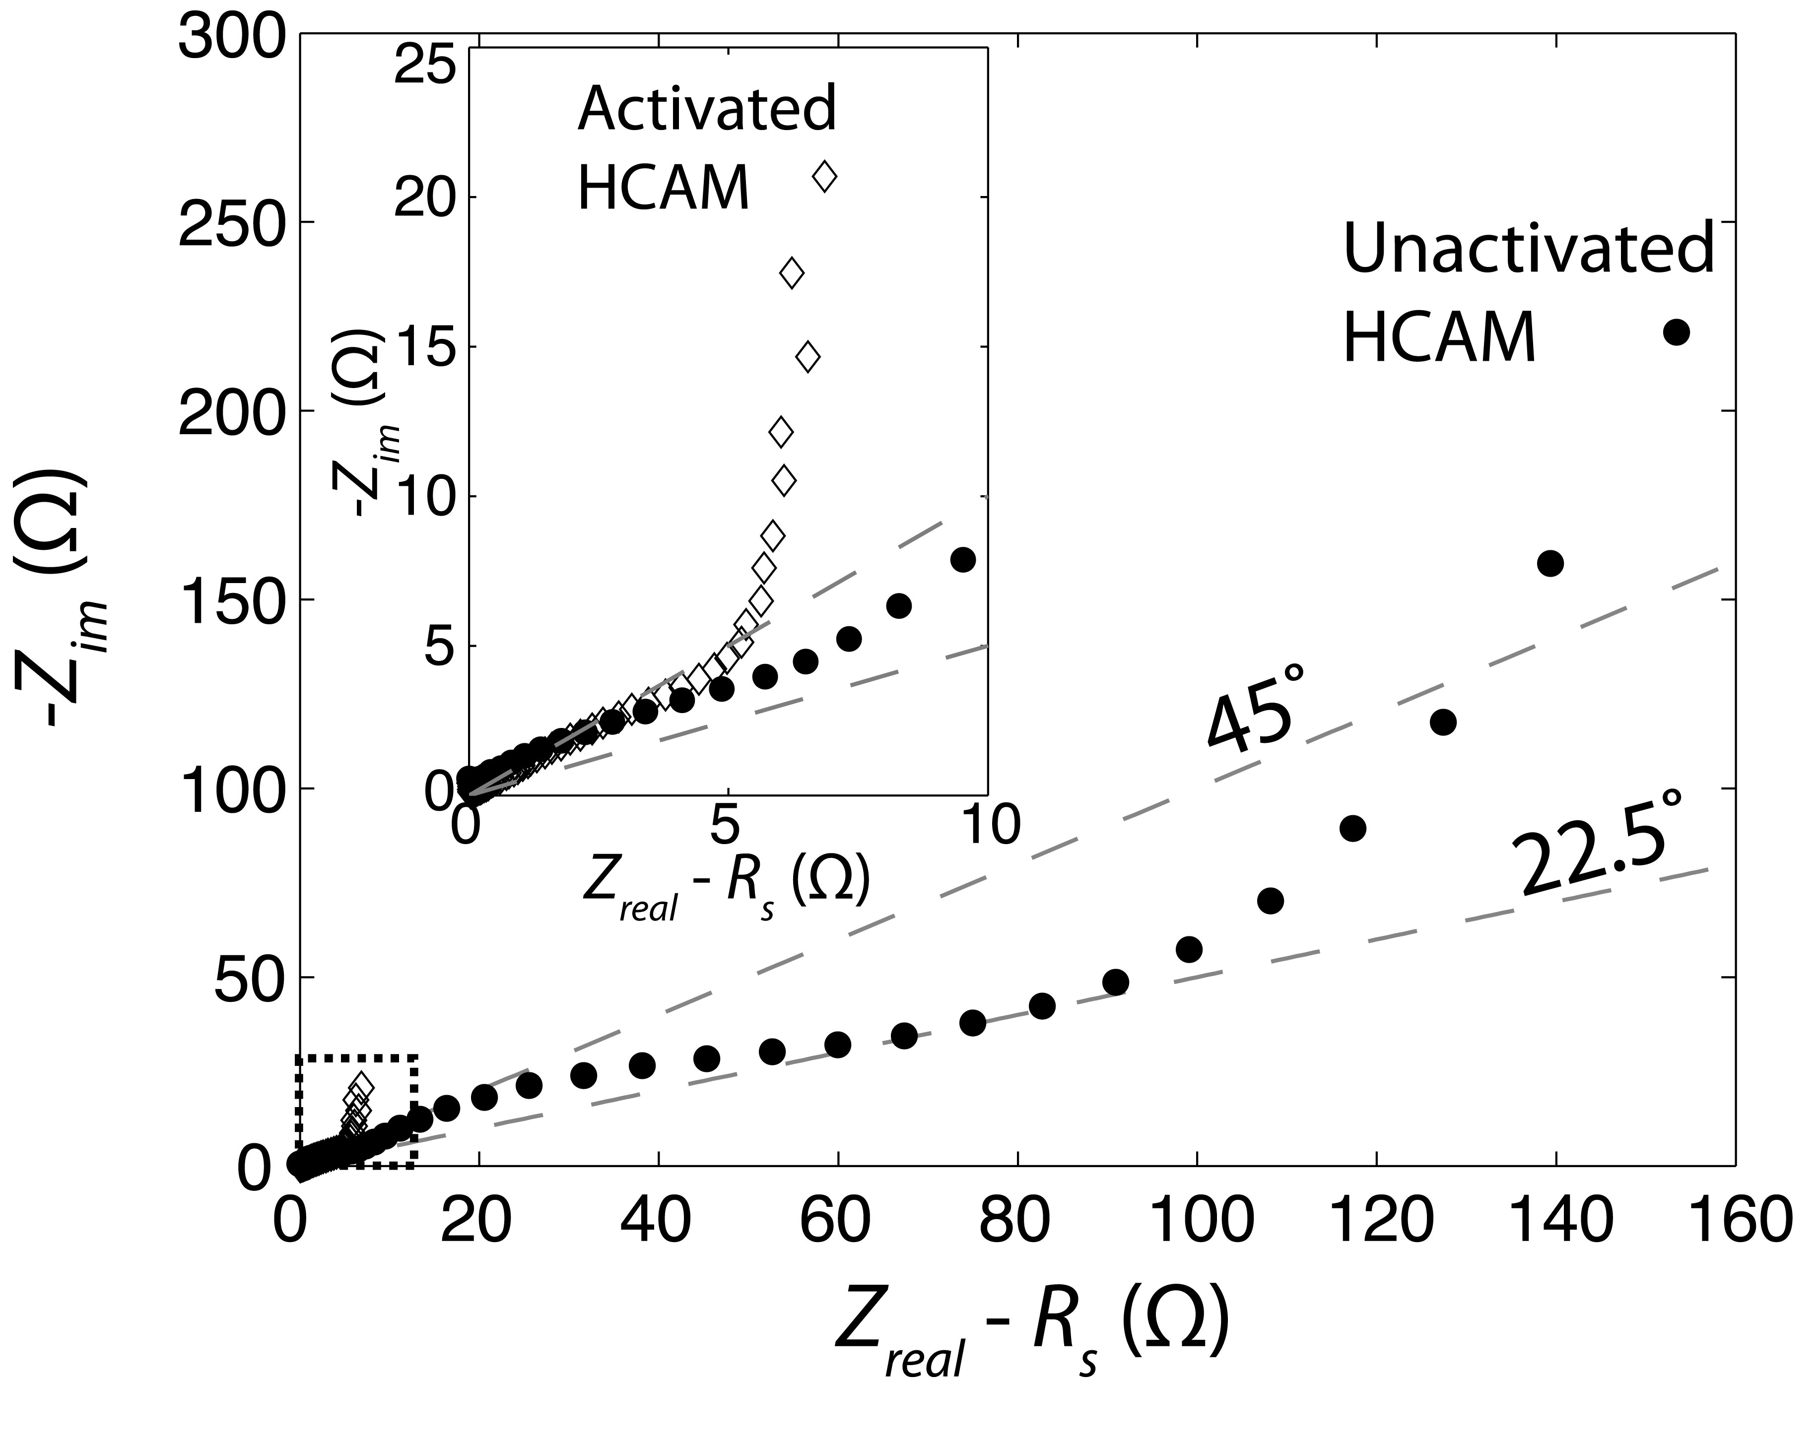
Figure SI3: Nyquist plot of impedance from EIS measurements for a 5 h activated HCAM electrode (hollow diamonds) and an unactivated HCAM electrode (black dots) at 0.5 M NaCl. Activation of the electrode results in approximately 20x reduction of the low frequency values of real impedance (the electrode resistance).

Appendix SI4: Sub-nm porous electrode parameters and circuit model
As described in the main paper, the unactivated HCAM electrode demonstrated a significant decrease in resistance and increase in capacitance with increasing voltage. We here present the details behind the calculations of the unactivated HCAM electrode’s resistance and capacitance values. We utilized the values from Table 1, column 1 to model the resistance and capacitance of the unactivated aerogel at a potential of 0.0 V. The electrode capacitance is C = C_{s} + C_{t} = 48.5 F/g, and the electrode resistance is R = (ρ_{s}+ρ_{t})*L/A = 73.9 Ω, where L = 0.8 mm is the electrode thickness in the electric field direction, and A = 28.2 mm² is the electrode cross-sectional area. At unactivated HCAM potentials of 0.5 and -0.5 V, we cannot reasonably fit our circuit model presented in the Theory Section to our measured EIS data, as our circuit model does not capture the semi-circular feature seen at high frequencies (see Figure 7b inset). Thus, we instead estimate the resistance and capacitance of the unactivated HCAM electrode at these potentials by using R = 3*Z_{real}(ω_{f}) and C = -1/ω_{f}Z_{im}(ω_{f}), where ω_{f} is 2π(10 mHz). From these calculations, the unactivated HCAM resistance and capacitance varies from 73.9 Ω and 48.5 F/g at 0 V to roughly 10 Ω and 92 F/g at 0.5 V (with similar resistance and capacitance also measured at -0.5 V).
In the inset of Figure 7b of the main paper, our EIS measurements of the unactivated HCAM electrode exhibited a high-frequency semi-circular feature at the higher electrode voltages. We here hypothesize that this feature may be due to transport limitations associated with ions entering the sub-nm storage pores of this material, and these limitations may be associated with the process of ion desolvation. In Figure SI4a, we present a preliminary circuit model which includes a resistance for ions entering the sub-nm pore, R_{sub-nm}. In Figure SI4b, we show the Nyquist plot representation of this circuit model for the case of R_{t} = R_{s} = 1 Ω, C_{t} = 0.01 F, C_{s} = 1 F, and R_{sub-nm} = 0.5, 1, 2, and 5 Ω, and a frequency range of 100 kHz to 100 mHz. These impedance curves show a prominent semi-circle at higher frequencies, and so this model may be a useful starting point for capturing the full frequency and voltage range of impedance data from sub-nm porous electrodes.
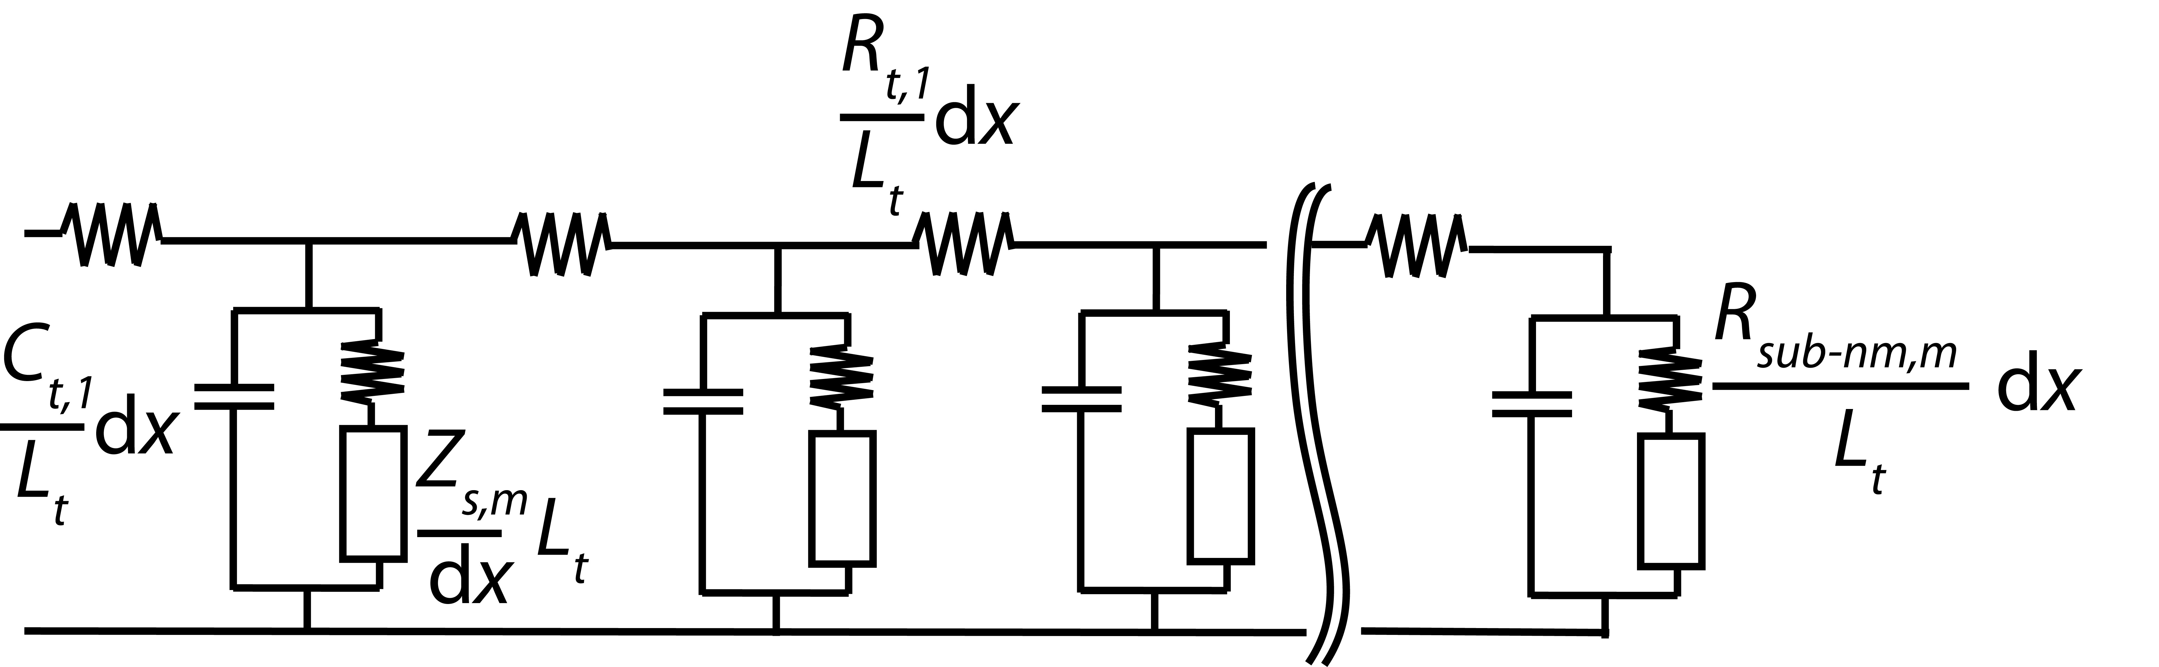

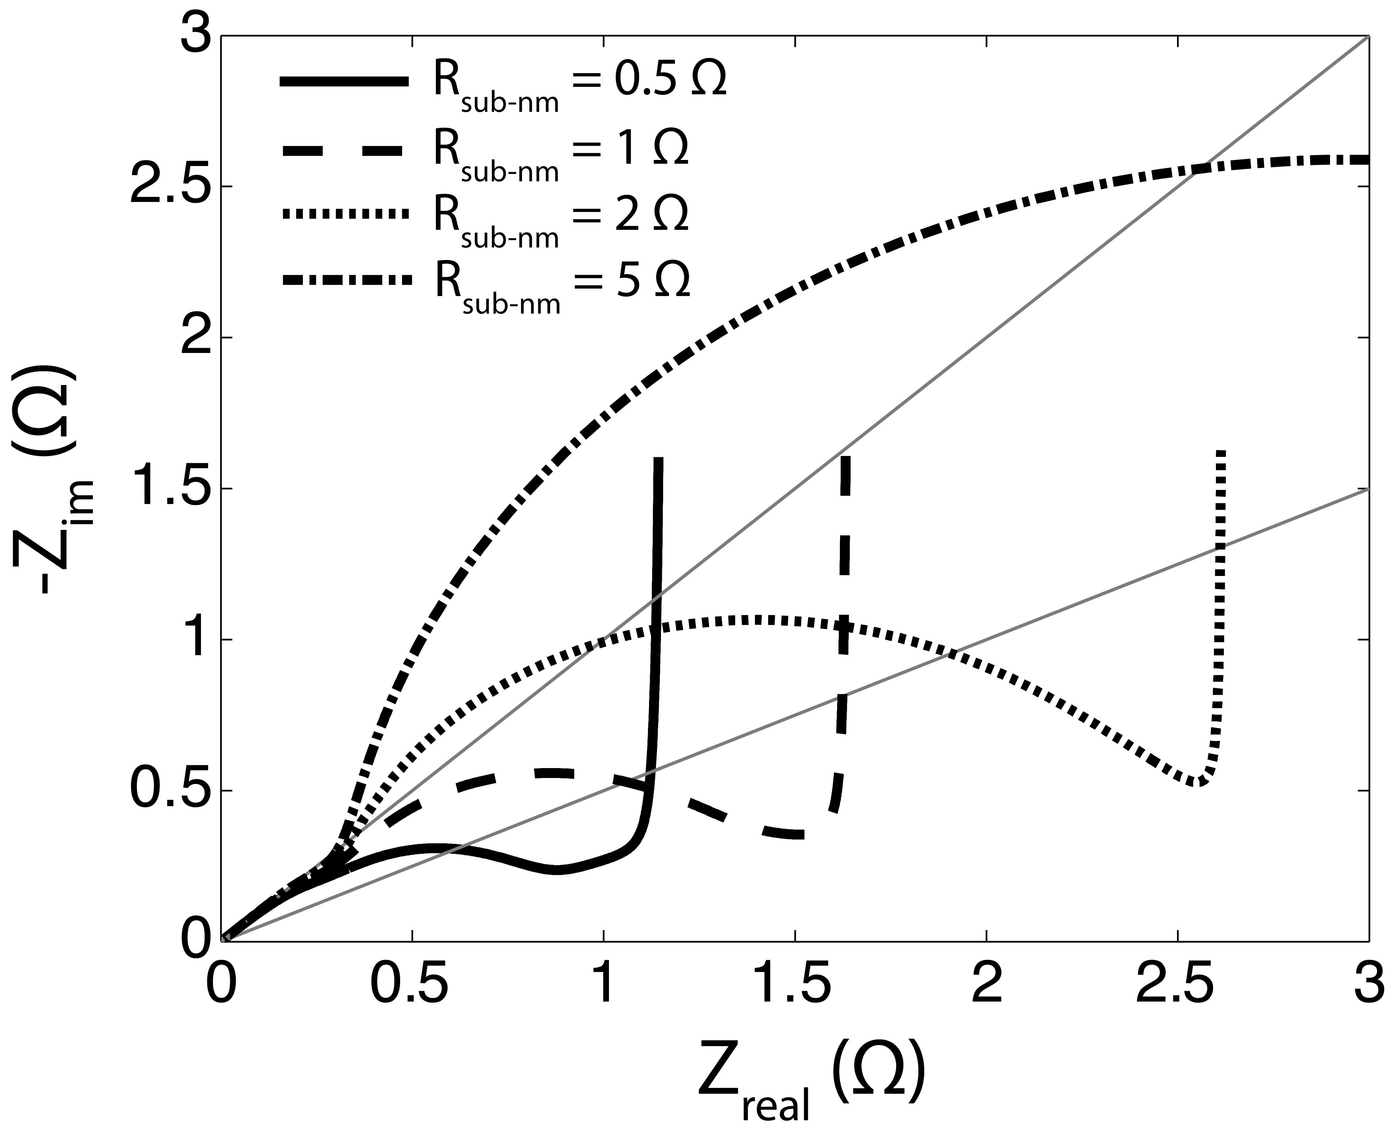
Figure SI4: a) Schematic of the nested transmission line circuit model including an extra resistance for ions entering the sub-nm storage pores, R_{sub-nm}. b) Model predictions for the cases of R_{sub-nm} = 0.5, 1, 2, and 5 Ω.

